Employee System Monitoring using Screenshots
M.Shivani¹ * Geethika Lingamaneni² * Sai Vineeth Poojari³ * Pooja Konduru⁴
¹ Asst. Professor in the Department of Computer Science and Engineering bat Sphoorthy Engineering College, Hyderabad, Telangana, India
Email: mshivani.cse@gmail.com
^{2,3,4} UG Student, Dept of Computer Science and Engineering, Sphoorthy Engineering College, Hyderabad, Telangana, India
Email: geethika.lg@gmail.com * saivineeth4546@gmail.com * poojakonduru95@gmail.com
---------------------------------------------------------------------***---------------------------------------------------------------------

Abstract – A Desktop Application where the screenshot of the employee’s system is taken in the given intervals and will be mailed to the manager or concerned higher official in the form of document. In this application, user or admin can check the employee’s work status and also assign the project details. The admin can add the employee upon joining and can assign the project or any other task whenever there is a necessity. This can be even implemented in colleges to monitor students and assign the assignments too.

Key Words: Application, Monitoring, Security, Real time desktop monitoring and controlling

1.INTRODUCTION

This application is useful to monitor the system. All the activities being done on the system can be monitored. This module helps you to track and analyze computer usage, easily to distinguish the wrong employee computer activities which can be a threat. This provides the system of record. Presenting detailed, accurate, and actionable data for incident response, high-risk insider monitoring, and productivity reporting, record every employee computer activities. All events in one solution, Screenshot recorder aims to maximize the value of every employee and to improve their productivity.

1.1 JAVA
Java is very powerful and popular language that supports the development of web-based applications. It provides a number of capabilities that complement those provide by JavaScript.
The rapid growth in the popularity of the java language is nothing short of a phenomenon. In less than a year, java went from a relatively unknown alpha version to an incredibly successful version 1.0 release. Every major computer hardware and software vendor has since endorsed Java. Its remarkable success is summed up by fact that Microsoft, its chief rival, not only supports java with Internet explorer, but also sells J++, a popular development environment. In this section we'll explore various aspects of Java.

1.2 HTML
Hyper Text Markup Language (HTML) is a method where ordinary text can be converted into hypertext. it is a set of special codes included to control the layout and appearance of the text. It is a set of special codes included to control the layout and appearance of the text. Technically, HTML is not a programming language.
- It combines instructions within data to tell a display program called browser, how to render the data that the document contains.
- HTML is the character-based method for describing and expressing the content. The content is pictures, text, sound, and video clips.
- It delivers the contents of multiple platforms.
- It links document components or documents together to compose compound documents.
Standard Generalized Markup Language:
HTML is a subset of SGML. SGML originated in 1960's at IBM to overcome the problems in moving the documents across the multiple hardware platforms and Operating Systems. IBM's efforts were called GML (General Markup Language). Later in 1980 SGML come into existence.

1.3 Java Server Pages (JSP):
Java Server Pages (JSP) is a Java technology that allows software developers to dynamically generate HTML, XML or other types of documents in response to a Web client request. The technology allows Java code and certain pre-defined actions to be embedded into static content.
The JSP syntax adds additional XML-like tags, called JSP actions, to be used to invoke built-in functionality. Additionally, the technology allows for the creation of JSP tag libraries that act as extensions to the standard HTML or XML tags. Tag libraries provide a platform independent way of extending the capabilities of a Web server.
JSPs are compiled into Java Servlets by a JSP compiler. A JSP compiler may generate a servlet in Java code that is then compiled by the Java compiler, or it may generate byte code for the servlet directly. JSP was developed by Sun Microsystems

JSP Architecture:
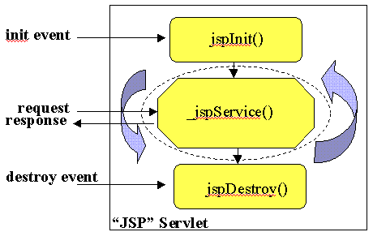

1.4 TOMCAT WEB SERVER
Tomcat is the Servlet Container (as well as JSP Engine) that is used in the official Reference implementation for the Java Servlet and Java Server Pages Technologies. The Apache Software Foundation (ASF) under the Jakarta Project has developed Tomcat. It has been developed as a 100% pure Java Application under an open-participatory process.
In its role as the standard reference implementation, Tomcat provides a good platform for developing and testing JSPs, since it enforces compliance with the published Specification. Tomcat is a container that is used to provide an environment for running Java code on a Web Server.
Version Used In The Application:
We used Tomcat 8.0 in our Application Development. This version is the implementation of the new JSP and Servlet 2.4 API Specifications.
There are significant changes that were made in Tomcat 8.0, which results in improved performance of login details and session termination.
It incorporates the following features:
  - Performance optimization and reduced garbage collection
  - Refactored application deployer allowing validation and compilation of a Web Application before putting it in production
  - Complete server monitoring
  - Improved platform integration with native Windows
  - Improved Taglib handling
  - Expanded Documentation

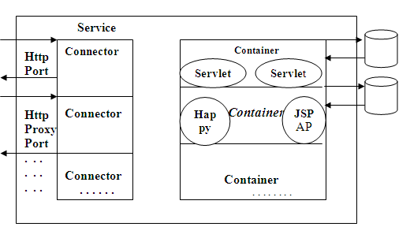
1.5 JAVA DATABASE CONNECTIVITY
JDBC is a Java API for executing SQL statements. (JDBC is as trademark and is not an acronym; JDBC is often thought of as understanding for "Java Database Connectivity"). It consists of a set of classes and Interfaces written in the Java Programming Language. JDBC provides a standard API for tool/database developers and makes it possible to write database applications using a pure Java API.
Using JDBC it is easy to send SQL statements to virtually any relational database. In other words, with the JDBC API, it is not necessary to write one program to access a Sybase database, another program to access a Oracle database, another program to access a Informix database, and so on..
1.6 OPEN DATABASE CONNECTIVITY
About ODBC:
Open Database Connectivity (ODBC) is a Microsoft standard for database access. It provides a mechanism for desktop-based tools (word processors, spreadsheets, report writers, Internet/Intranet tools, for example) to transparently access data sources, such as databases. Open Link Software provides the drivers you need to access your data sources from an ODBC compliant application.
ODBC Working
A typical single-tier installation may consist of a database server, and a client that comprises the client networking provided by the database engine vendor and the Open Link Like ODBC driver. The client components need to be installed on every PC that is going to access the data. The ODBC driver must be accompanied by an application, such as Microsoft Office, which will use the driver to access and manipulate the data.

2. EXISTING SOLUTION
At present if the manager of the company wants to check his employee’s status, he or she has to wait till the deadlines to check whether the work is being done or not. If the work is not done then it may be a issue for both the manager as well as the employee to meet the deadlines of the project.

3. PROPOSED MODEL
A detailed and easy access application through which the manager or the admin can add the employees and monitor them easily and even assign projects through it.
The employees upon being added gets his user name and password through which he has to login on to his machine to do his work. Starting from the login time till he/she logs out the system will be monitored via screenshots i.e., the screenshots are captured for the given time interval and all the screenshots of a particular employee will be mailed to who ever is concerned.
With this the activities of the employees are monitored and thus there will not be any sort of manipulations and provides security to the data also.

3.1 SYSTEM ARCHITECTURE

- Admin activities:
Admin

Add Employee
View Employee
Add/Assign Project

Employee Details

- Flow of action:
User

Daily login

Automatic Screenshot Captured

Screenshots mailed to concerned person

4. CONCLUSION
This application can be used any where, wherever there is a necessity for systems to be monitored. It can be used for monitoring employees, students in colleges, Internet cafe’s and many other areas too. Modifications can be made to this to make it useful in various areas.

4.1 BENEFITS
Improve Employees Productivity
Investigate Toxic Employees
Easy Time Tracking
Real Time Desktop Monitoring
Prevent Productivity Loss
Protect Valuable Corporate Data
Prevent Potential Internal Threats

5.REFERENCES
[1] I Corner, B Rogers, Journal of Targeting, Measurement and Analysis for Marketing
[2] WR Rassman, BM Berman, S Blau, A Chiang - US Patent 4,937,743, 1990 - Google Patents.
[3]S.A.M. Advanced Management Journal , Summer98, Vol. 63 Issue 3, p4, 11p.
[4]P Brosch, M Seidl, K Wieland, M Wimmer… - Proceedings of the 24th …, 2009 - dl.acm.org.
[5] X Shang, K Yu - US Patent App. 14/579,309, 2018 - freepatentsonline.com
[6] Laadan, RA Baratto, DB Phung, S Potter… - ACM SIGOPS Operating …, 2007 - dl.acm.org
[7] T Sasaki, S Morisaki… - 2011 Joint Conference of …, 2011 - ieeexplore.ieee.org
[8] N Moraveji - US Patent App. 11/277,130, 2007 - Google Patents

BIOGRAPHIES
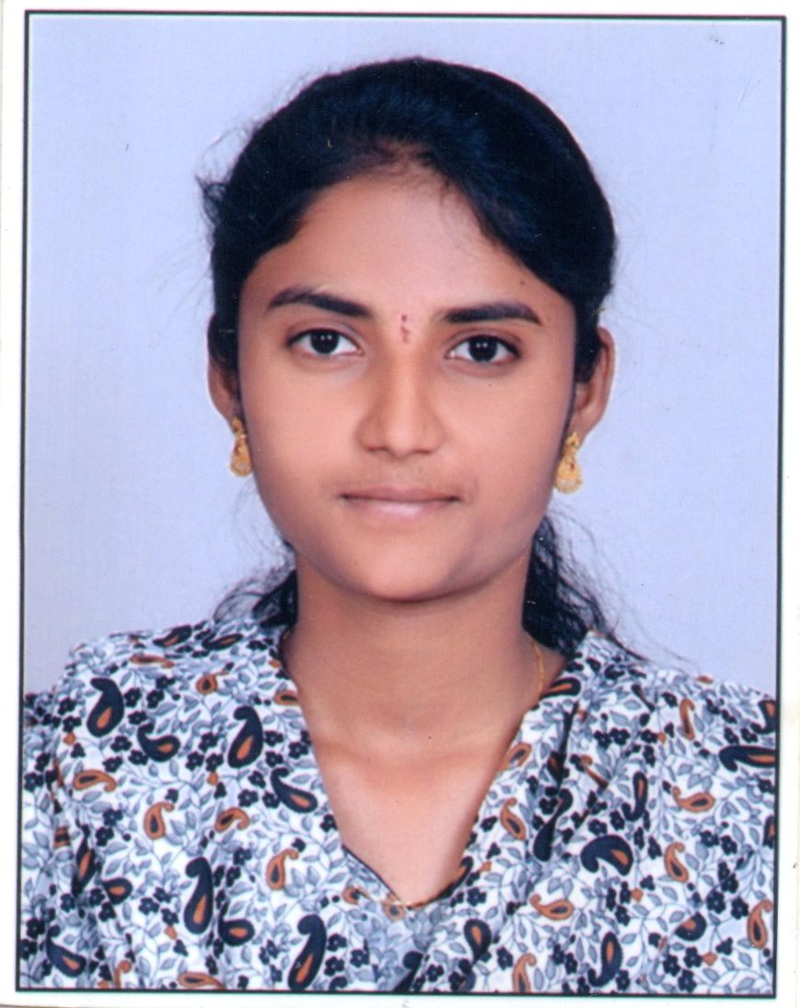 | Shivani M is currently working as an Asst. Professor in the Department of Computer Science and Engineering at Sphoorthy Engineeirng College, Hyderabad, Telangana.

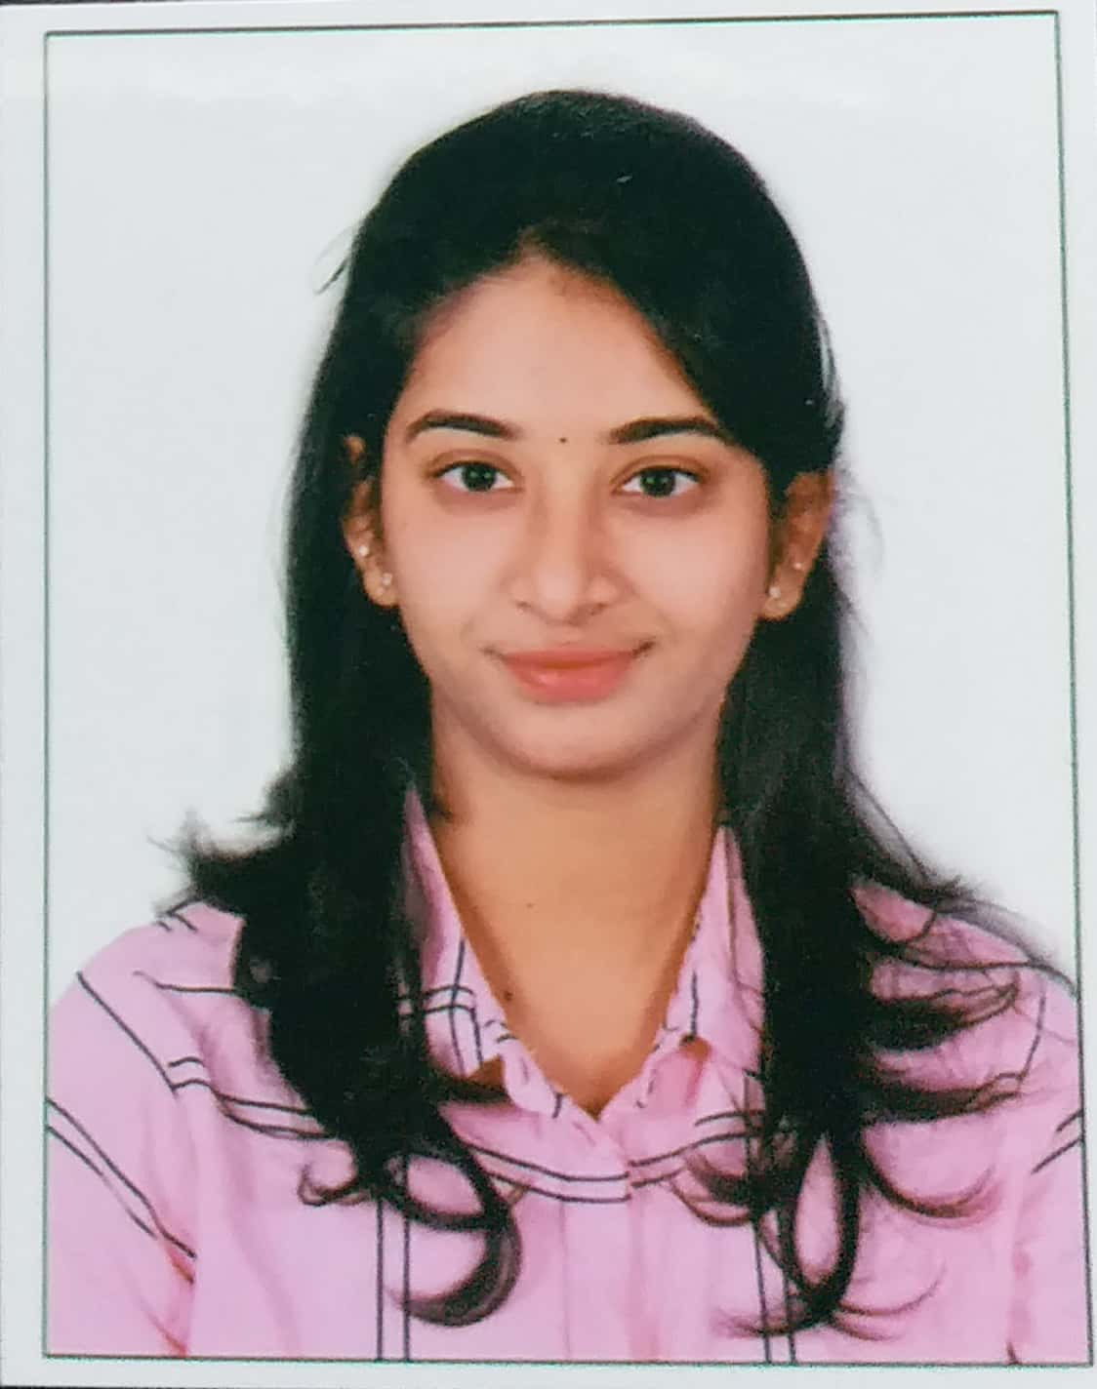 | Geethika Lingamaneni is a student from Hyderabad currently pursuing B.Tech Computer Science and Engineering from Sphoorthy Engineering College.
 | Sai Vineeth Poojari is a student from Hyderabad currently pursuing B.Tech Computer Science and Engineering from Sphoorthy Engineering College.
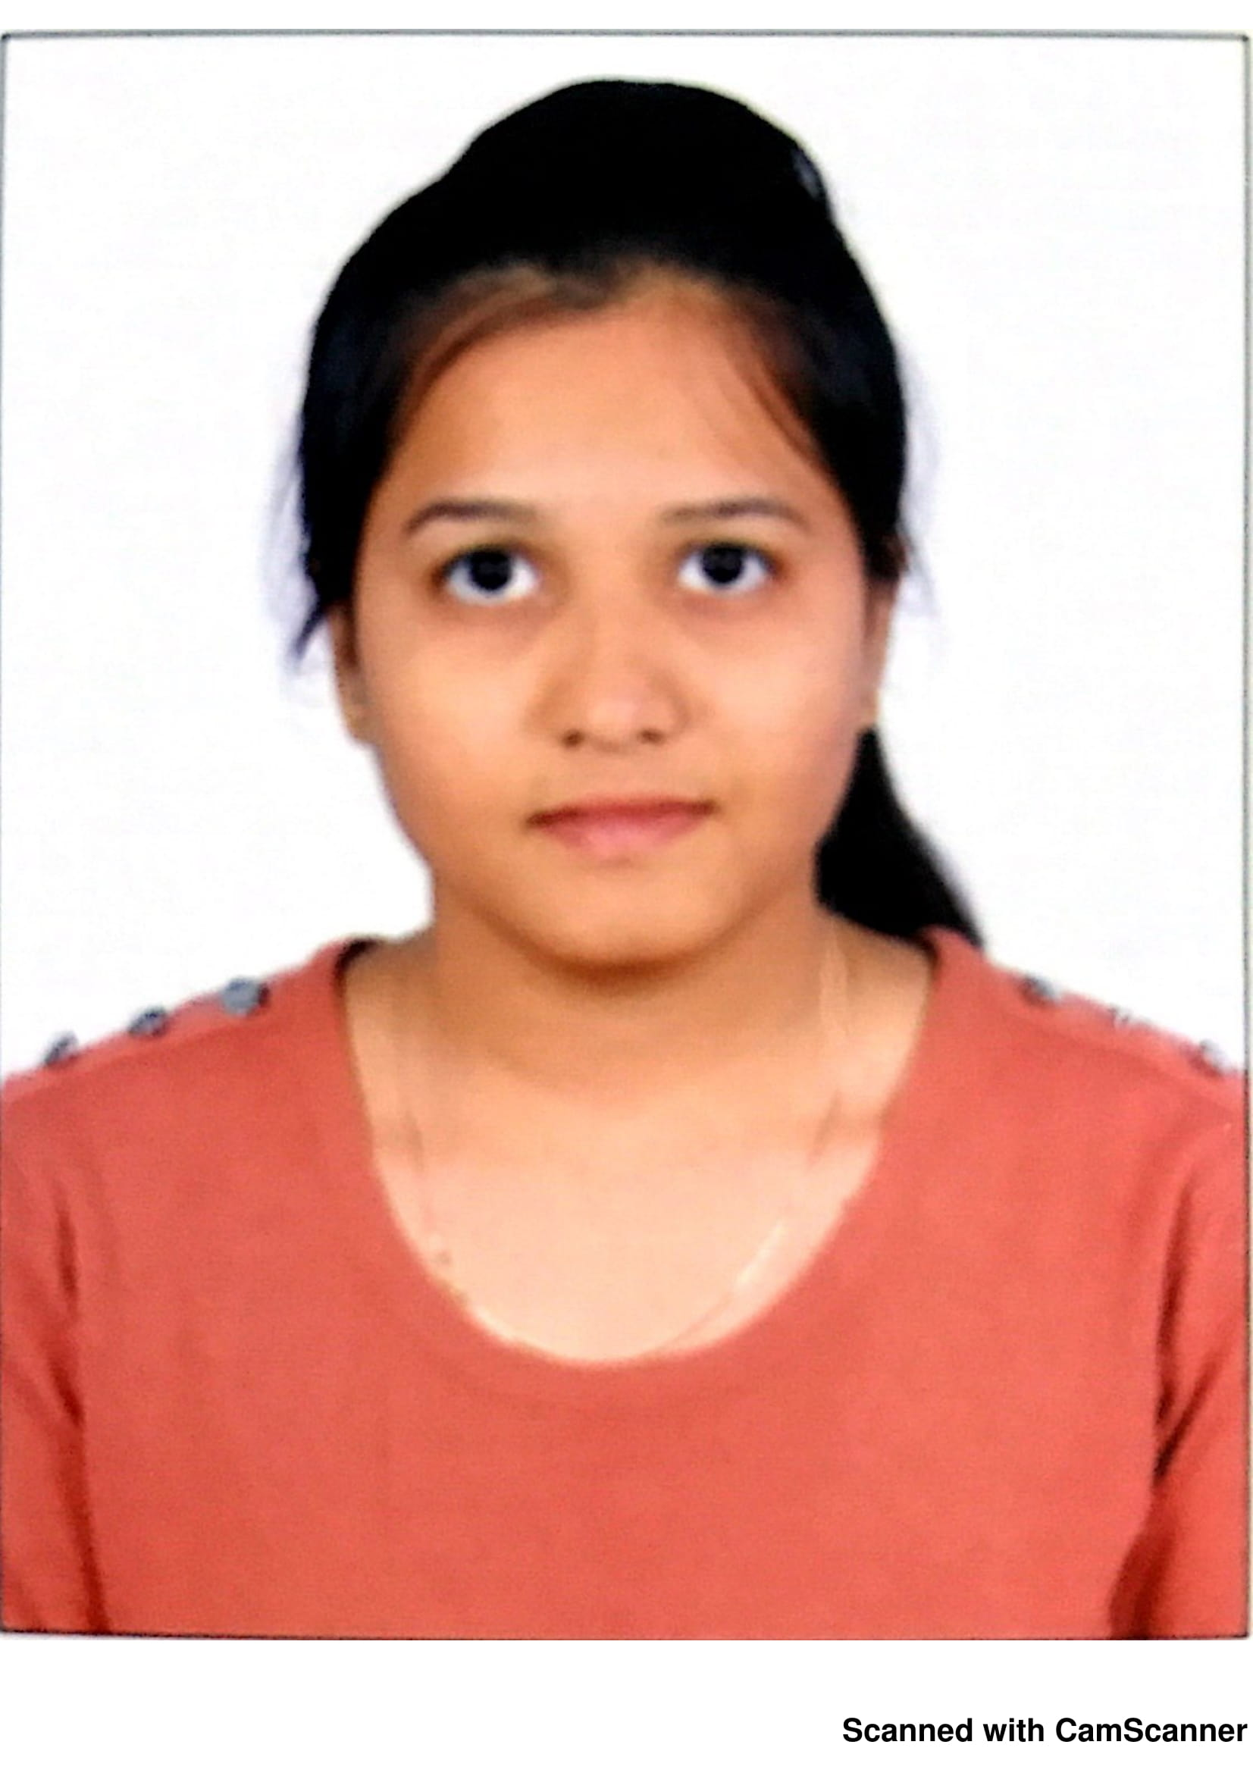 | Pooja Konduru is a student from Hyderabad currently pursuing B.Tech Computer Science and Engineering from Sphoorthy Engineering College.

